NORTH ATTLEBORO FIREFIGHTERS
KIDS DAY ASSOCIATION

INVITES YOU

33rd ANNUAL FIRE APPARATUS
PARADE

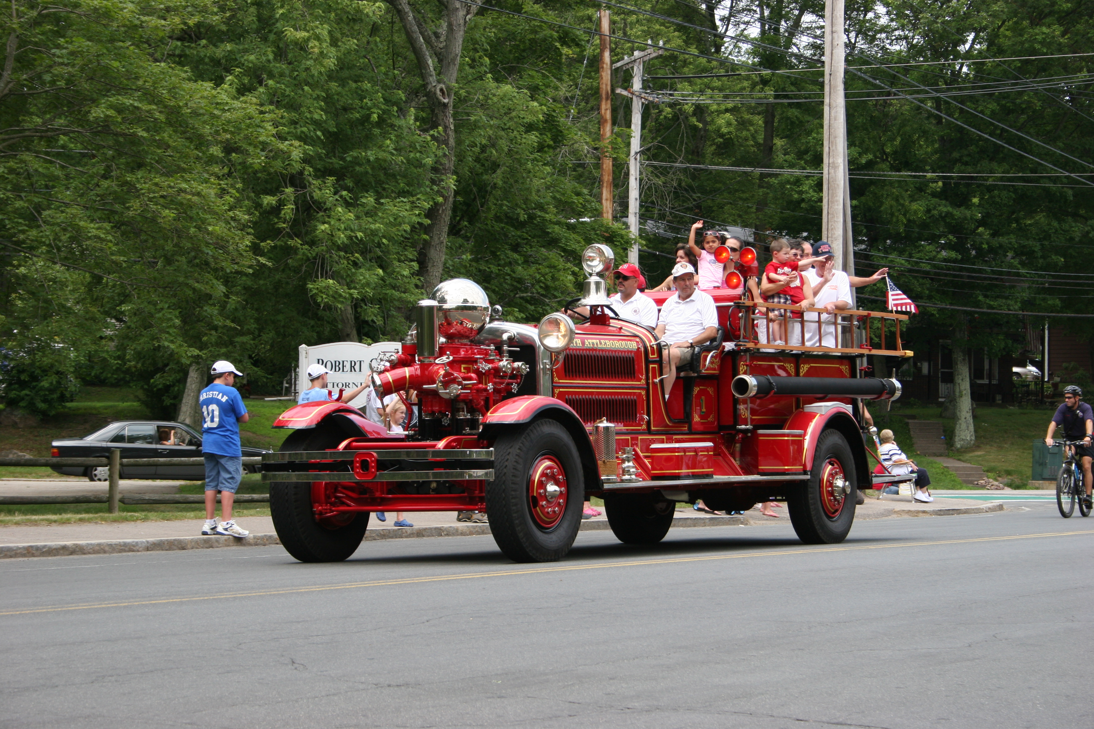

SATURDAY JULY 13, 2013
SET UP AND REGISTRATION
North Attleboro High School
Parking lot
570 Landry Ave
10:00
AWARDS
10:45
PARADE START 11:00
ALL ATTENDING WILL RECEIVE OUR ANNUAL PARADE PIN
PLEASE RSVP CHRIS CORNETTA
cica1022@aol.com OR 508-320-5806

