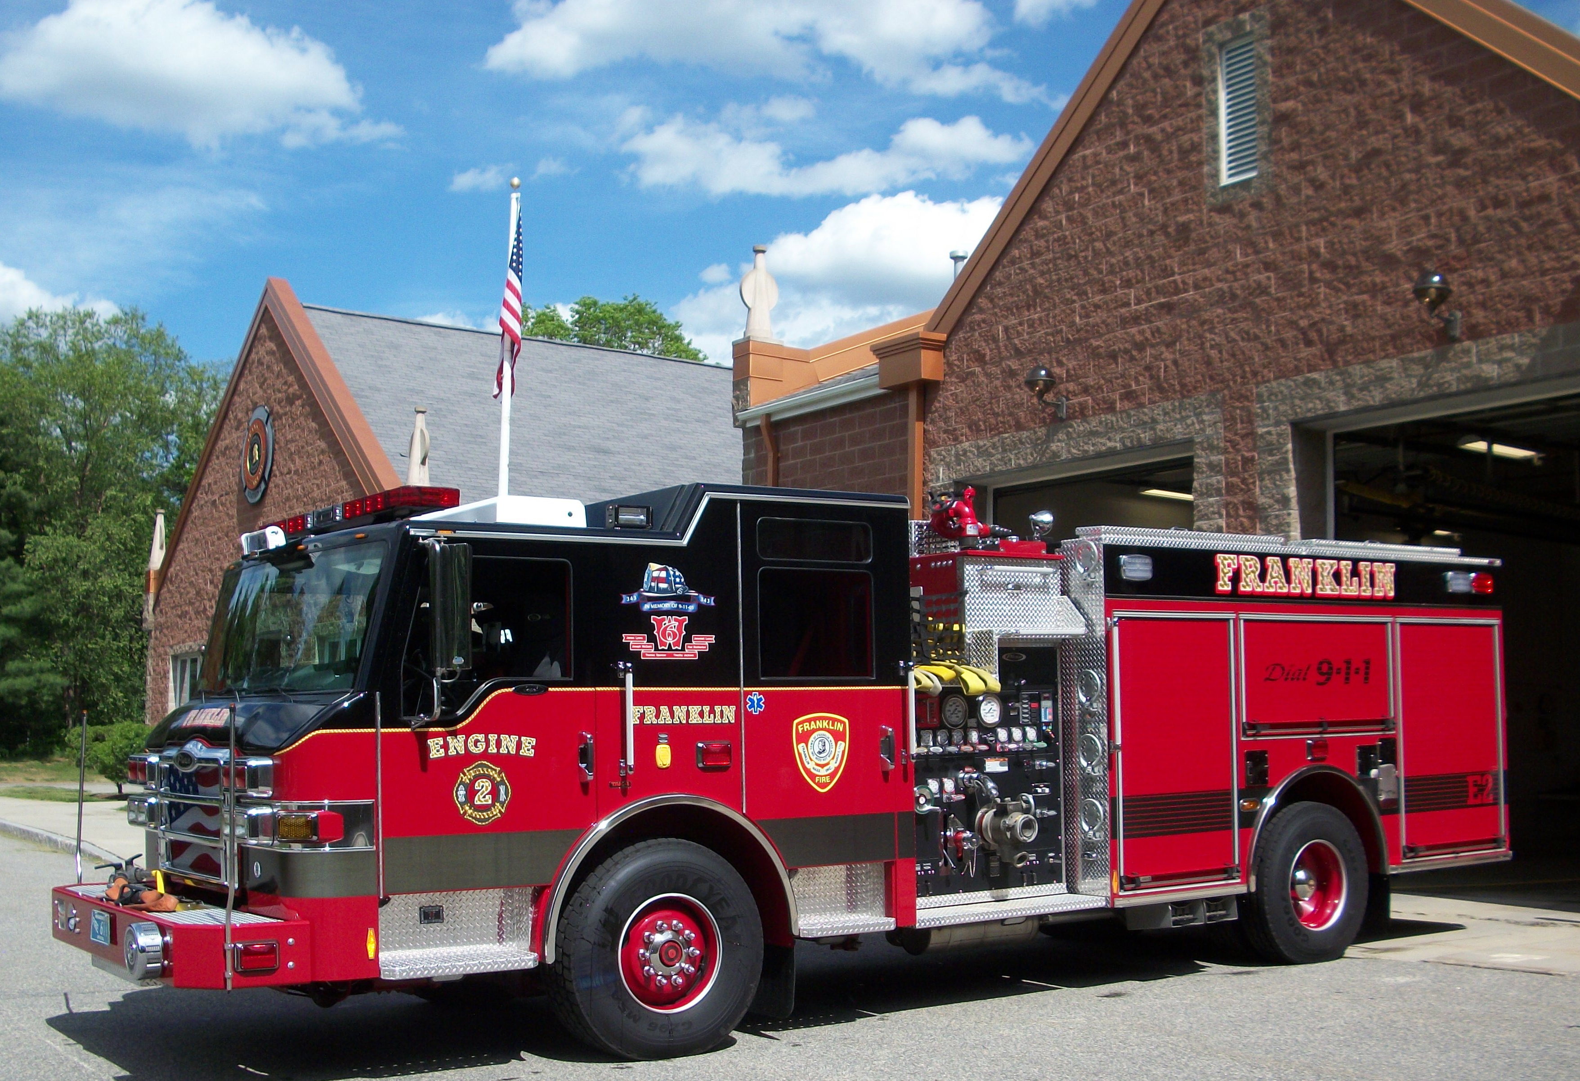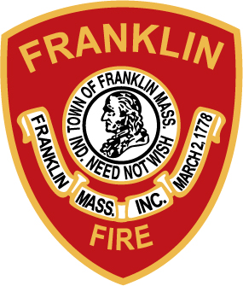
YOU’RE INVITED!!

WHAT? 2013 Fire Apparatus Parade

WHEN? Sunday July 7, 2013 - 12:30PM Set-Up (Begin Line-Up)
1:50PM Step Off (Parade Starts)

WHERE? Franklin, Massachusetts
Station 2 Located @ 600 King Street

WHO? YOU & YOUR DEPARTMENT’S APPARATUS!!

The Franklin Fire Department invites you to join in and show your department’s apparatus & other vehicles with pride. We have trophies in 6 categories for our parade participants. Newest Apparatus In Service, Oldest Apparatus In Service, Best Antique, Furthest Distance Traveled, Best Specialty Unit, and Best of 2013 Parade trophies will be presented.
The parade steps off promptly at 1:50PM from the staging area behind Fire Station #2 located @ 600 King Street, (Interstate 495/ Exit 16). Lunch will be provided prior to the parade. Antique fire apparatus are welcome. If you have questions, or need directions, please feel free to contact Joe Barbieri at
(508) 528-2323, or e-mail questions to jbarbieri@franklin.ma.us. We look forward to seeing everyone July 7th!!

