Walpole's 56th Annual
FIRE APPARATUS PARADE
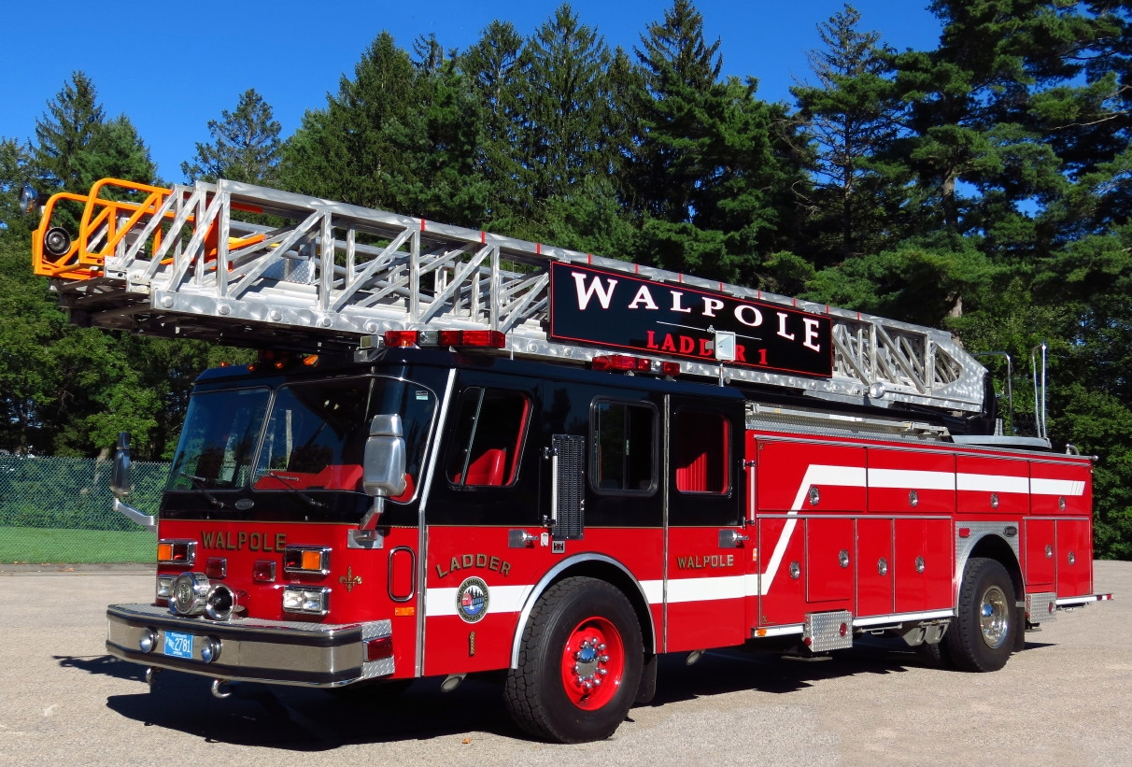 | 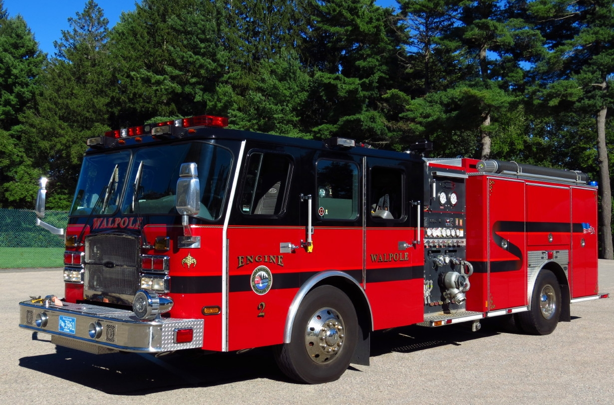 | 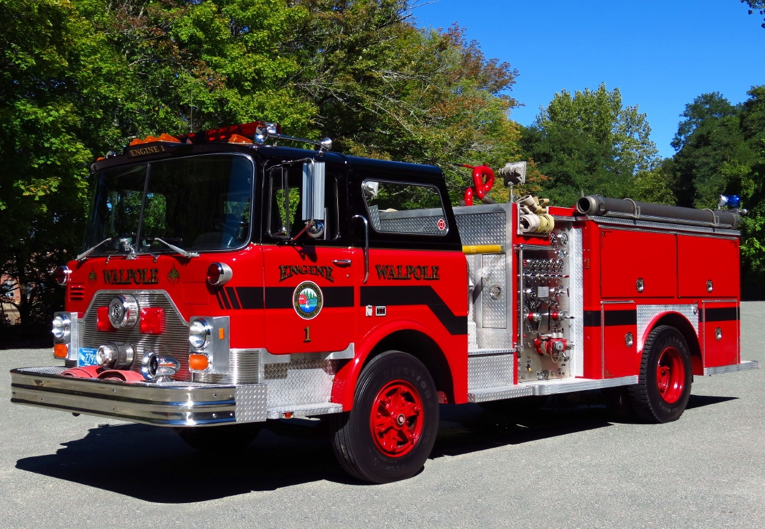

CHANGE OF DATE!!!

DATE: SUNDAY JULY 6, 2014 - 5:00PM Sign-In
6:00PM Parade

STAGING: East Street Between June & Washington Streets
East Walpole, Massachusetts

ROUTE: Washington to Short to East to Main to Common

The Walpole Fire Department welcomes all from near and far to be part of our 2014 Annual Fire Apparatus Parade. We have trophies to be awarded for Newest Engine In Service, Newest Ladder In Service, Oldest Engine In Service, Oldest Ladder In Service, Furthest Distance Traveled, Best Rescue/Specialty Unit, Best Tanker, Best Brush Piece, Best Antique and BEST OF 2014 PARADE will be presented.

The parade steps off promptly at 6PM. Apparatus can access the staging area by turning onto June Street from Washington, then Right onto East Street. Personnel & signs will be there to assist. Following the parade, an assortment of food & refreshments will be provided to any and all participants. Please feel free to contact Lieutenant Peter Carter at Walpole Fire, (508)668-0260, or e-mail questions & RSVPs to walpoleparade@comcast.net. We hope to see one and all again this year for our Parade!

