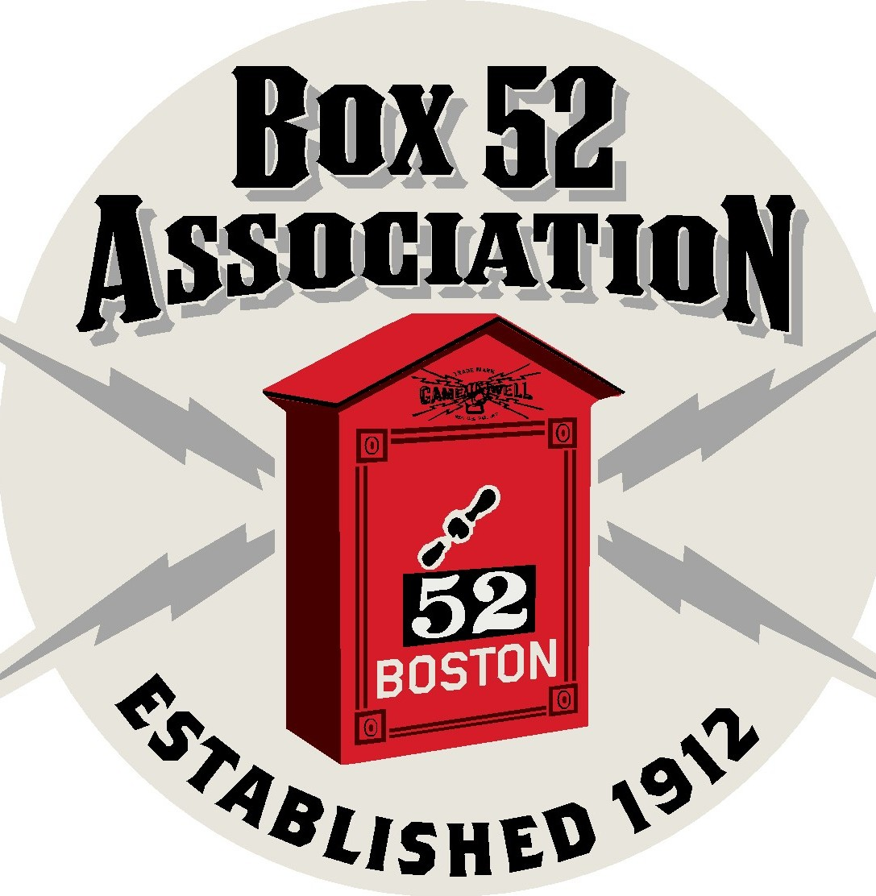
Join the Box 52 Association for our last Centennial Year event!
Quaboag River Area
Fire Departments Bus Tour
Including: Palmer, Sturbridge, Ware, Charlton and others!
Saturday June 15th, 2013 rain or shine!
Tickets are $ 30.00 per person with a box lunch
Departs from Everett 0830 hours, Returns 1730 hours
For more information, or tickets contact:
Bill Wilderman bwilderman@firefire.com
Box 52 Association thelinebox@hotmail.com

