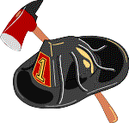
Annual Labor Day Parade and Muster Activities
Monday September 1, 2008 (Rain or Shine)
Parade Line up: 10:00 AM Parade Time: 11:45 AM
Food Served 12:00 PM Muster Events 1:00 PM
Fire Trucks from area towns will line up at 10:00. Parade will start at 11:45 from the Groton Senior Center and go toward the H & V Field on Townsend Road (W. Groton).
Activities include: Boy Scout Troop 1 –Yard sale Food: Hamburgers
Demonstrations Hot Dogs
Muster Games Chicken
Kids Games Drinks: Soda & Water


